**WEEK-3**

**SPRING CORE AND MAVEN**

**Exercise 1: Configuring a Basic Spring Application**

**CODE:**

**STEP 1: Created a Maven project named LibraryManagement**

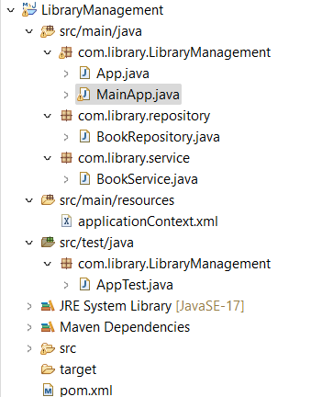

**Added Spring Core dependencies in the pom.xml**

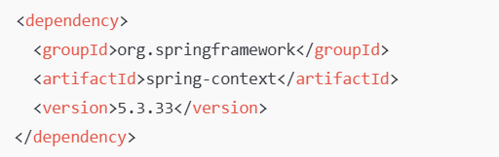

**Step 2: Created applicationContext.xml in src/main/resources**

**And Defined beans for BookService and BookRepository**

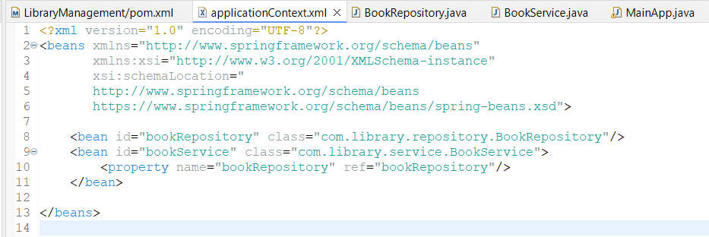

**Step 3:**

**Created a package com.library.repository and add a class BookRepository.**

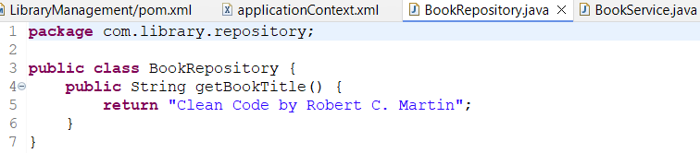

**Created a package com.library.service and add a class BookService.**

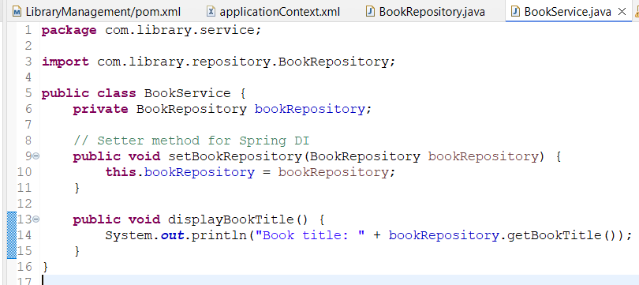

**Step 4:**

**Created a main class to load the Spring context and test the configuration.**

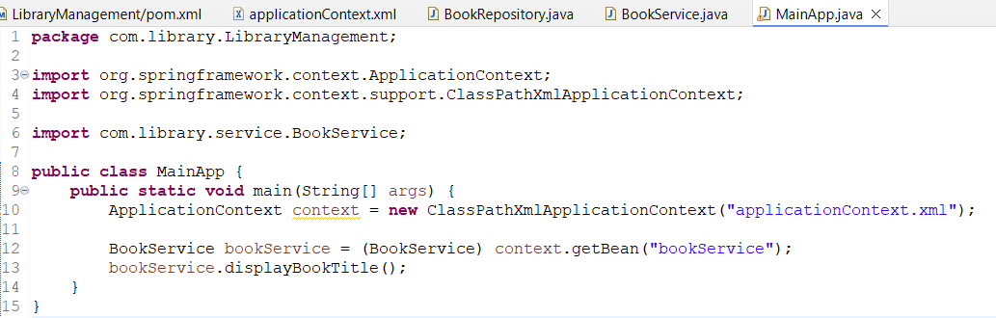

**OUTPUT:**



**Exercise 2: Implementing Dependency Injection**

**CODE:**

**Step 1: Modified the XML Configuration**

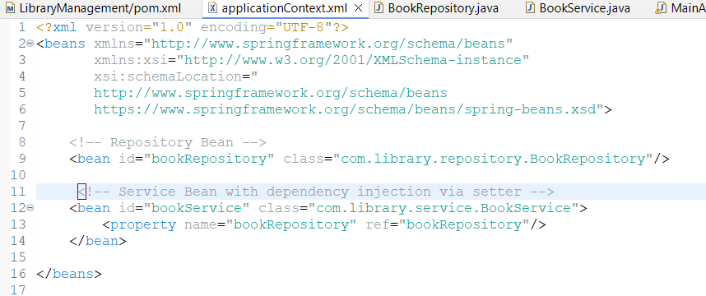

**Step 2: Updated the BookService Class**

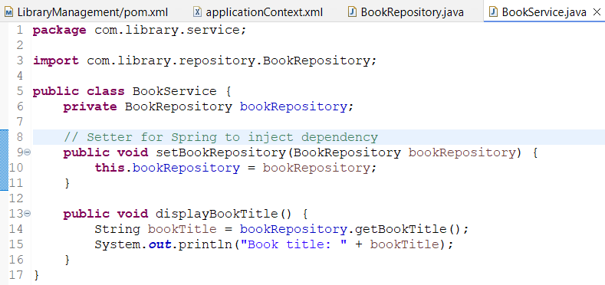

**Step 3: Tested the Configuration**

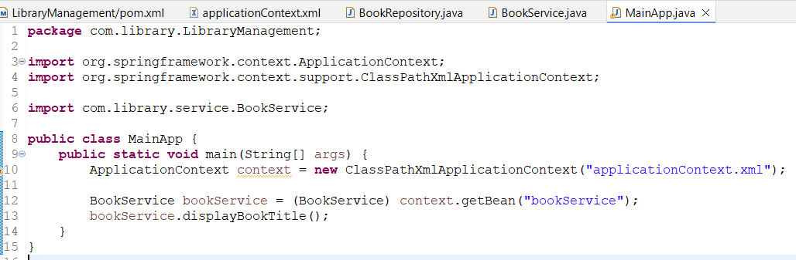

**OUTPUT:**



**Exercise 4: Creating and Configuring a Maven Project**

**OUTPUT:**

**CODE:**

**Step 1: Created a New Maven Project**

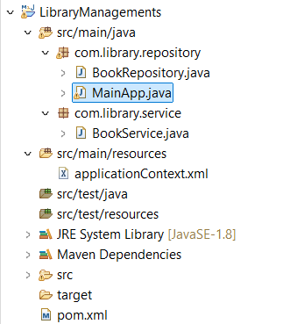

**Step 2: Added Spring Dependencies in pom.xml**

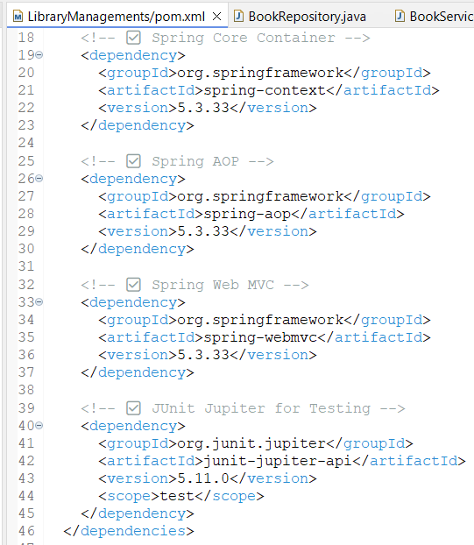

**Step 3: Configured the Maven Compiler Plugin**

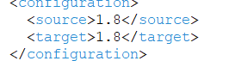

**Name: Manjeet Swaroop**

**SuperSetId: 6393474**

**EmailID:** [**manjeet.swaroop@gmail.com**](mailto:manjeet.swaroop@gmail.com)